**Imp Note:- There my maby user,group and otheres may exsist in the system but uid is the only thing that differnetiate them.**

**UID of any user can be checked by first going into that user window and write command echo $UID**

**.The UID of the user will be printed.**

**UID of root is always 0**

**read**

**This cmd is used to take input from the user**

mkdir

rmdir

cp

mv

cd

ls

pwd

sudo apt-get install

sudo apt-get update

sudo apt-get upgrade

sudo apt-get remove filename/sofware

touch file name

cat

tac:-Print the content in reverse order

clear

touch . :-create a hidden file

ls - a ~~:-~~lsit all file

history:-gives the histroy

ls-l :-list all long files

ls-r:- list all the files in reverse order

ls-t:-list all the file as per time

sudo su:- makes the user as super user .User can acess the root priviliges without usig sudo again and again.

Note:-To exit frm the user mode press ctrl+D

chmod permissions filename

top :-It will list all the process running iin the environment

ps:-list all the running process

kill process id:-This kills the process id .

Kill - 9 <process id>:-It kills the process abruptly

sudo nano:-opens the editor

free -g :- Tells the memory in gb

Note:-for getting the memory into kilobytes,meagabytes,bytes use k,m,b respectively in place of g.

Sudo ./ software name which needs to be run

ls -al filename (to check the permissions)

man cmdName:-will tell the history of the command.

hostname:-will tell the name of host server

hostname - i:- will tell the ip address

echo Hello>>note.txt :-It will add hello to note.txt

date:-Prints the date

**cut command**:-It is used to get the particular byte,char,word,adding delimeter between words.

File name:-name.txt

1.cut -b 1,2,3 name.txt

For more knowledge

<https://www.geeksforgeeks.org/cut-command-linux-examples/>

**Cmd to set environment in linux**

set :-gives the list of environment variables

export <variblename>=<path>

Sets shows al the global variable names in operating system.

Env:- env cmd shows the environment variables only

unset variable name

delets the environment variable

**Grep cmd:**-It is used to get the particular sequene of characters

There are many options used with grep cmd like -i , -c,-o,-w,-E,-l,-h

-l list all the files which have common word present in a directory.

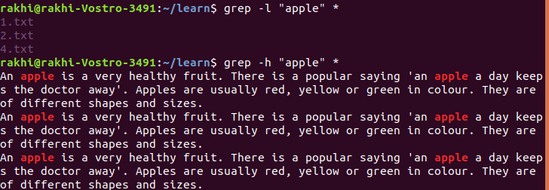

-l :- is used for listing only file names.

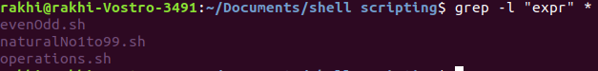

-h used for highliting the word but it do not print the file name

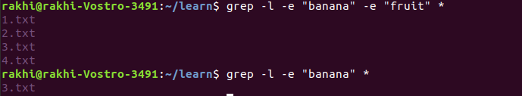

-e :- it used for finding many words.

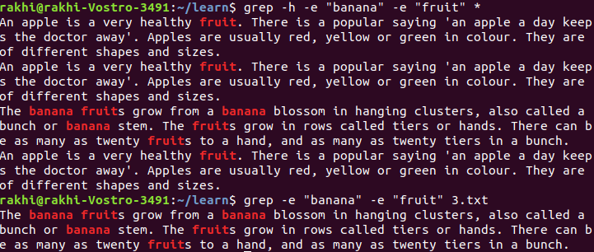

In grep when we want to search multiple words ina file then the cmd is

grep ‘the\|those\|that\|then’

The above cmd will serch for all the words

for more check her

<https://www.geeksforgeeks.org/grep-command-in-unixlinux/>

**tr cmd**

It is used for the transformation or deletion of words.

Many options are used along with tr cmd

- c :- complements the output asked

for eg:- cat learn.txt| tr -cd ‘n’

This cmd will delete all words except n.

- d:- deletes the given value from the file and prints the output

for eg:- cat learn.txt| tr -d ‘n’

-s :- squeeze the various occurences into one

for eg:- cat learn.txt| tr -s ‘n’

**sort command**

It is used to sort the file.

Many options are used along with it

1-o

It is used to transfer the sorted answer into another file.

sort -o learn.txt>learn1.txt

This will sort the contet of learn and store the content in learn1.txr.

Cmd can also be written as

sort learn.txt>learn1.txt

2-r

Sort in reverse order

3.-n

sort the numbers

4.-k Option :

Unix provides the feature of sorting a table on the basis of any column number by using -k option.

5.-c

checks whetehr the file is sorted or not .

If the file is sorted then nothing will print else the first unsorted line will print.

6.-u

It removes the duplicates

7.-M

sort as per month name

8.-t :-

to give deilimeter along with -k

for eg sort -t$’\t’ -k 2 -n -r <filename>

this will sort list in descending order as per second column where tab is differentiating two column.

**head cmd**

It is used to print the top lines of file.

Options used along with it are:-

1. - n:- It tells the no of top lines to be printed

for eg:- head -n 10 learn.txt

2.-c :-It is used to print the chearacters from first to specified position

head -c 20 <filename>

**tail cmd**

It is used to print the lines from downward

**ssh command**

It is used to login to remote linux(which is probablty on cloud).

It provides a public key to lauch the remote linux system so the command is

ssh -i <public key file location> <username>@<ipaddress>

Now the remote linux will be visible on terminal and we can write the commands on that remote linux server.

No gui will be there for remote linux.

**expr cmd**

**It s used for mathematicla operation**

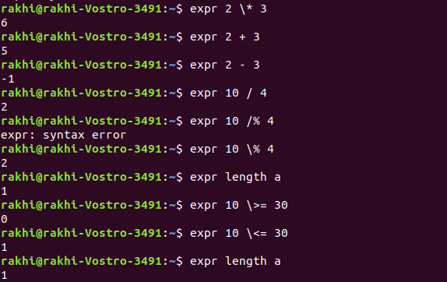

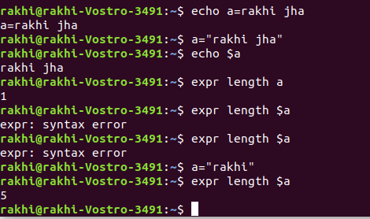

**Header file of shell script is shebang**

**Shebang is #! :-This represents which interpreter should be used for interpreting**

**#!/bin/bash:- This is headre file which represents it is a bash/shell script**

**#!/bin/bash is this is not provided it often considers #!/bin/sh which would be same in mot cases.When you put #!/bin/bash in your script,even if you run the script in a different shell ,the kernel will know which shell to interpret it with.**

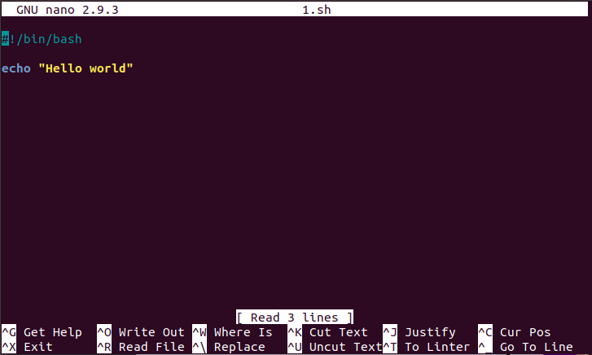

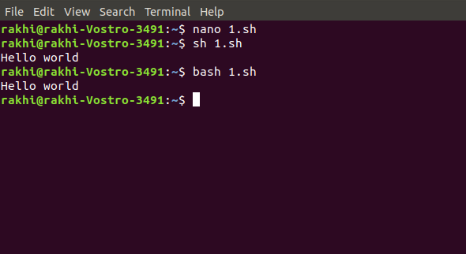

**How to add another user**

sudo useradd <username>

**How to add group**

sudo groupadd grp1

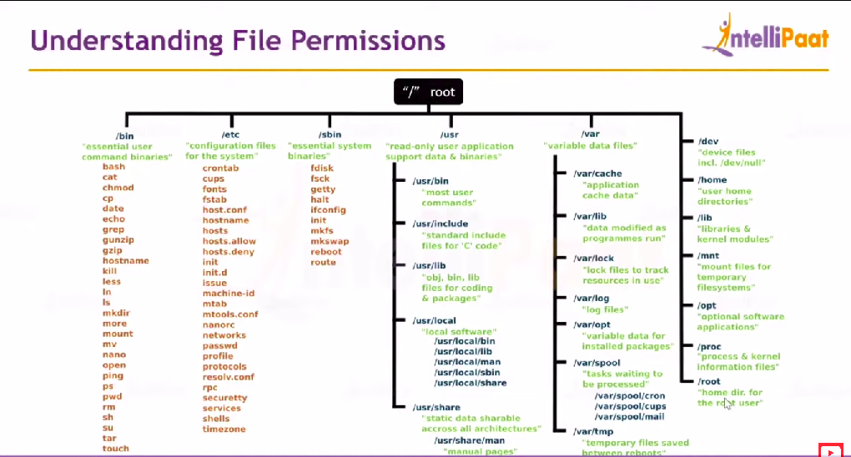

**Ownership Permission**

chown is used

chown username filename :- gives permission of file to the mentioned user.

chown groupname filename :- gives permission of file to the mentioned group.

chown username:groupname filename :- gives permission of file to the mentioned userand group both.

**Find cmd**

find <filename>

It will search whether the file exsist in the directory or not.

**File cmd**

It will tell what type of file it is like directory,text,shell script.

Find <name of file>

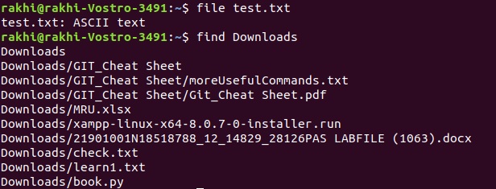

**Unix Process Control Commands**

**A command issued in unix/linux starts a new process which invokes a 5 digit unique id called pid.Using pid the process can be tracked.**

**ps aux**

**shows all the process running**

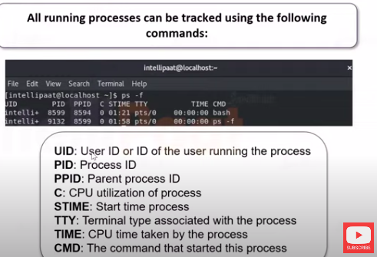

**ps -u username**

**It shows all the process running in the mentioned user account**

awk cmd

Awk is a utility that enables a programmer to write tiny but effective programs in the form of statements that define text patterns that are to be searched for in each line of a document and the action that is to be taken when a match is found within a line. Awk is mostly used for pattern scanning and processing. It searches one or more files to see if they contain lines that matches with the specified patterns and then performs the associated actions.

Eg:-awk ‘/search word/ {print}’ <filename>

If else in awk pattern

eg:- 1.awk`{

    if(($2+$3+$4)/3>=80)

    {

        print $1,$2,$3,$4,":","A"

    }

    else if(($2+$3+$4)/3>=60&&($2+$3+$4)/3<80)

    {

        print $1,$2,$3,$4,":","B"

    }else if(($2+$3+$4)/3>=50&&($2+$3+$4)/3<60)

    {

        print $1,$2,$3,$4,":","C"

    }else

    {

        print $1,$2,$3,$4,":","FAIL"

  }

}`

2.awk `{print $1,$2,“:”,($4==””)?”Pass”:”Fail”}` <filename>

**file cmd**

It tells the type of file

file <filename>

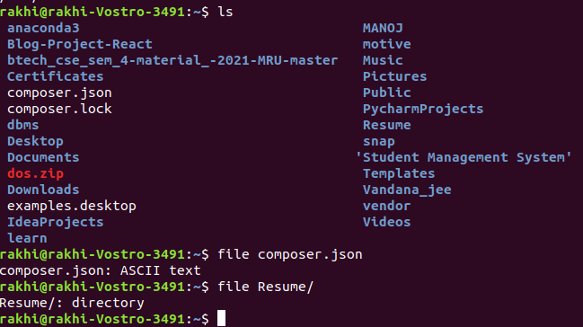

**cmd to find the location of any** [**file by using below cmd :-**](../../../../-)

**file / -name “name of file”**

